 | 12.1.28 Editors - Geometry Nodes Editor - Header - Add Menu - Mesh Topology
Table of content
Detailed table of content 1
Add menu - Mesh - Topology 3
Corners of Edge 3
Corners of Face 3
Corners of Vertex 4
Edges of Corner 5
Edges of Vertex 5
Face of Corner 6
Offset Corner in Face 6
Vertex of corner 6

Detailed table of content
Detailed table of content
Detailed table of content 1
Add menu - Mesh - Topology 3
Corners of Edge 3
Input 3
Face Index 3
Weights 3
Sort Index 3
Outputs 3
Corner Index 3
Total 3
Corners of Face 3
Input 4
Face Index 4
Weights 4
Sort Index 4
Outputs 4
Corner Index 4
Total 4
Corners of Vertex 4
Input 4
Vertex Index 4
Weights 4
Sort Index 4
Outputs 4
Corner Index 4
Total 4
Edges of Corner 5
Input 5
Corner Index 5
Outputs 5
Next Edge Index 5
Previous Edge Index 5
Edges of Vertex 5
Input 5
Vertex Index 5
Weights 5
Sort Index 5
Outputs 5
Edge Index 5
Total 5
Face of Corner 6
Input 6
Corner Index 6
Outputs 6
Face Index 6
Index in Face 6
Offset Corner in Face 6
Input 6
Corner Index 6
Offset 6
Outputs 6
Corner Index 6
Vertex of corner 6
Input 7
Corner Index 7
Offset 7
Outputs 7
Vertex Index 7

Add menu - Mesh - Topology
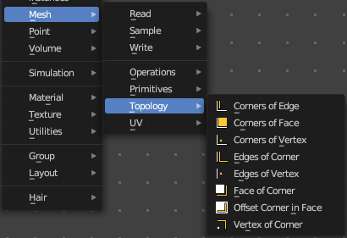
Mesh topology related nodes.

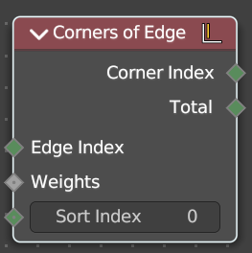
Corners of Edge
Retreive the corners that makes up a edge.

Input

Face Index
The face to get the data from.

Weights
Values used to sort the corners of the face.

Sort Index
Which of the corners to output.

Outputs

Corner Index
The output corner.

Total
The number of corners in the face.

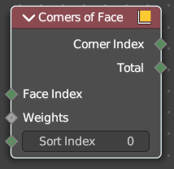
Corners of Face
Retreive the corners that makes up a face.

Input

Face Index
The face to get the data from.

Weights
Values used to sort the corners of the face.

Sort Index
Which of the corners to output.

Outputs

Corner Index
The output corner.

Total
The number of corners in the face.

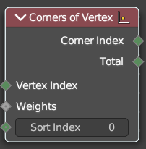
Corners of Vertex
Retreive face corners connected to vertices.

Input

Vertex Index
The vertice to get the data from.

Weights
Values used to sort the corners attached to the vertice.

Sort Index
Which of the corners to output.

Outputs

Corner Index
The output corner.

Total
The number of corners connected to each vertice.

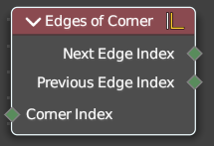
Edges of Corner
Retreive the edges of both sides of a corner.

Input

Corner Index
The corner to retreive the data from.

Outputs

Next Edge Index
The edge behind the corner.

Previous Edge Index
The edge before the corner.

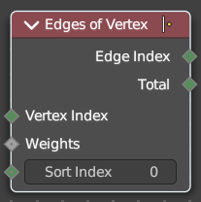
Edges of Vertex
Retreive the edges connected to each vertex.

Input

Vertex Index
The vertice to get the data from.

Weights
Values used to sort the edges attached to the vertice.

Sort Index
Which of the edges to output.

Outputs

Edge Index
The output edge.

Total
The number of edges connected to each vertice.

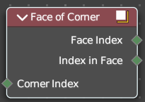
Face of Corner
Retreive the faces connected to each corner.

Input

Corner Index
The corner to get the data from.

Outputs

Face Index
The output faces.

Index in Face
The index of the corner, starting from the first corner in the face.

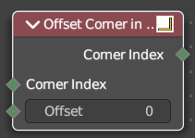
Offset Corner in Face
Retreive corners within the same face as another

Input

Corner Index
The corner to get the data from.

Offset
The numbers of corners to move around the face before getting the result. It circles around the start of the face if necessary.

Outputs

Corner Index
The index of the offset corner.

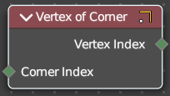
Vertex of corner
Retreive the vertex each corner is attached to.

Input

Corner Index
The corner to get the data from.

Offset
The numbers of corners to move around the face before getting the result. It circles around the start of the face if necessary.

Outputs

Vertex Index
The vertex each corner is attached to.

